**OOAD PROJECT**

**<HOTEL MANAGEMENT SYSTEM >**

**Software Requirements Specification**

**For <HOTEL MANAGEMENT >**

**Version <1.0>**

**Revision History**

|  |  |  |  |
| --- | --- | --- | --- |
| **Date** | **Version** | **Description** | **Author** |
| **<9/12/2021>** | **<1.0>** | The project, Hotel  Management System is a web-based application that allows the hotel manager to handle all hotel activities online. Interactive GUI and the ability to manage various hotel bookings and rooms make this system very flexible and convenient | 11166 Adeel  11180 Haris |

**Table of Contents**

1. Introduction 3

1.1 Purpose 4

1.2 Scope 4

2. Overall Description 4

3. Specific Requirements 5

3.1 Functionality 5

3.1.1 <Functional Requirement One> **Error! Bookmark not defined.**

3.10 Licensing Requirements 6

3.11 Legal, Copyright and Other Notices 6

1. UML Diagrams of Transaction Form 8
   1. AS IS Diagrams 4.1.1 Use Case Diagram.
      1. Use Case Narration
      2. Activity Diagram
      3. Sequence Diagram
      4. Collaborative Diagram
      5. State Chart Diagram
      6. Class Diagram
   2. To Be Diagrams 4.2.1 Use Case Diagram.
      1. Activity Diagram
      2. Sequence Diagram
      3. Collaborative Diagram
      4. State Chart Diagram

**Software Requirements Specification**

# 1. Introduction

The project, Hotel Management System is a web-based application that allows the hotel manager to handle all hotel activities online. Interactive GUI and the ability to manage various hotel bookings and rooms make this system very flexible and convenient. The hotel manager is a very busy person and does not have the time to sit and manage the entire activities manually on paper. This application gives him the power and flexibility to manage the entire system from a single online system. Hotel management project provides room booking, staff management and other necessary hotel management features. The system allows the manager to post available rooms in the system. Customers can view and book room online. Admin has the power of either approving or disapproving the customer’s booking request. Other hotel services can also be viewed by the customers and can book them too. The system is hence useful for both customers and managers to portable manage the hotel activities.

## 1.1 Purpose

The purpose of the Hotel Management system is to generate bills and item details to the customer. The clear understanding of the hotel management and its functionality will allow for the correct software to be developed for the end user and will be used for the development of the future stages of the project.

## 1.2 Scope

The software to be developed deals with creating a Hotel Management system which will automate the major hotel operations such as generating Customer Order Detail, billing and keeping track of records of daily transaction. Admin have the authority to control and modify the database.

# 2. Overall Description

* **Product perspective**

The Hotel Management System is a new self-contained software product which will be produced by the project team in order to overcome the problems that have occurred due to the current manual system. The newly introduced system will provide an easy access to the system and it will contain user friendly functions with attractive interfaces. The system will give better options for the problem of handling large scale of physical file system, for the errors occurring in calculations and all the other required tasks that has been specified by the client. The final outcome of this project will increase the efficiency of almost all the tasks done at the Hotel in a much convenient manner.

* **Product functions**
  1. Make Reservations
  2. Search Rooms
  3. Add Payment
  4. Manage Room Types (Add, Update, Delete)
  5. Manage Room Details (Add, Update, Delete)
  6. Manage User Role (Add, Update, Delete)
  7. Manage Users (Add, Update, Delete)
  8. Manage Generate Database Backup through Application

* **User characteristics**

01: Users/Customer 02: Admin



Users



Admin



R



eceptionist



* **Constraints**

Software development crew provides their best effort in developing the system. In order to maintain the reliability and durability of system, some design and implementation constraints are applied. When designing interfaces of system, we had the capability of work with new tools. Considering the client’s budget, we decided to create those interfaces in a simple realistic manner using affordable technology.

* **Assumptions and dependencies**

# 3. Specific Requirements

## 3.1 Functionality

1. Make Reservations
2. Search Rooms
3. Add Payment
4. Manage Room Types (Add, Update, Delete)
5. Manage Room Details (Add, Update, Delete)
6. Manage User Role (Add, Update, Delete)
7. Manage Users (Add, Update, Delete)
8. Manage Generate Database Backup through Application

**3.2 Interfaces**

3.2.1 User Interfaces / Software Interfaces

Dashboard

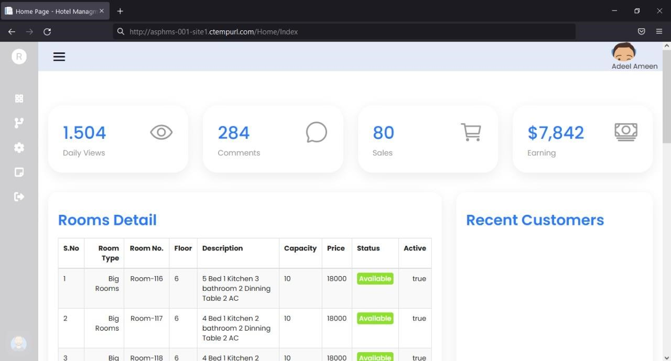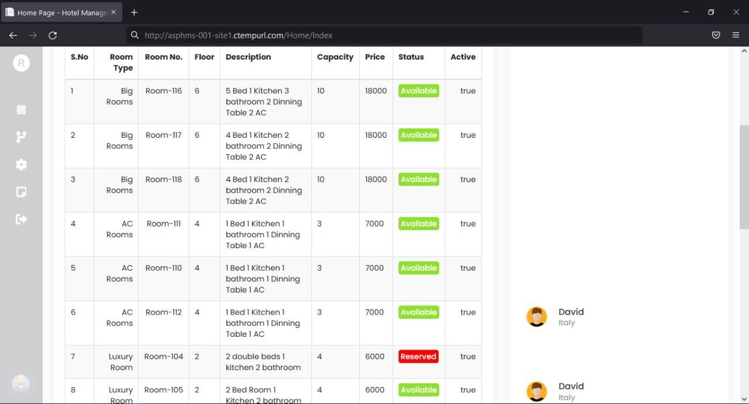

ROOM TYPE

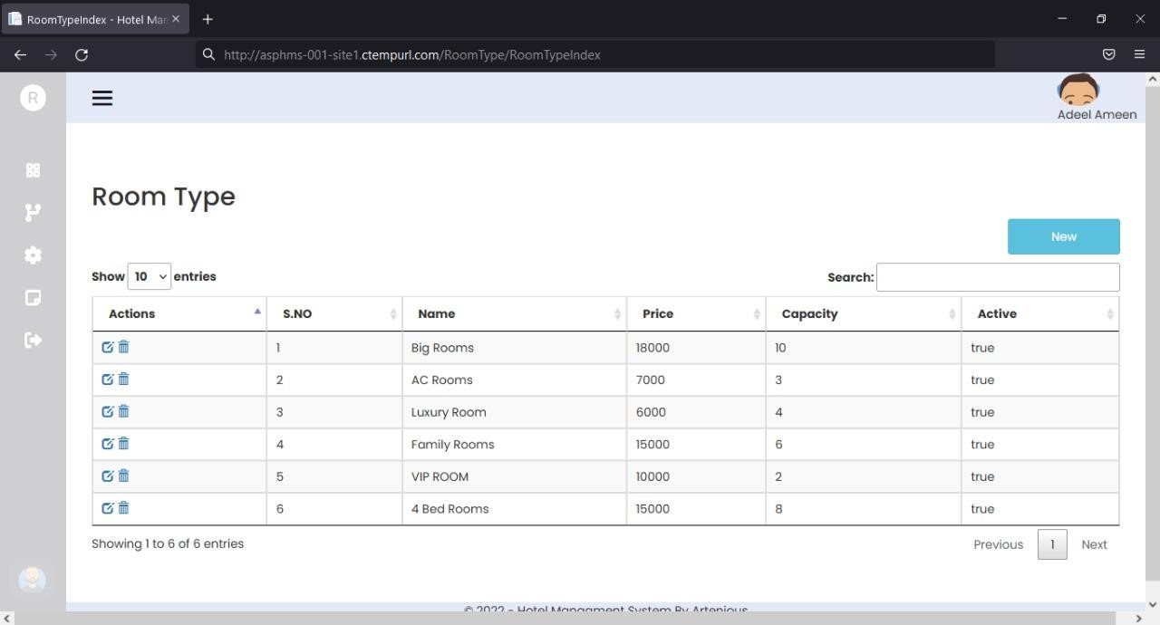

ROOM INFORMATION

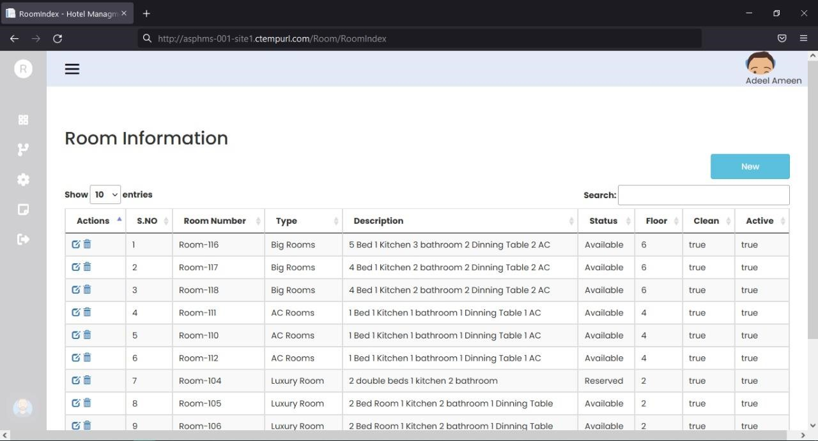

CUSTOMER INFO

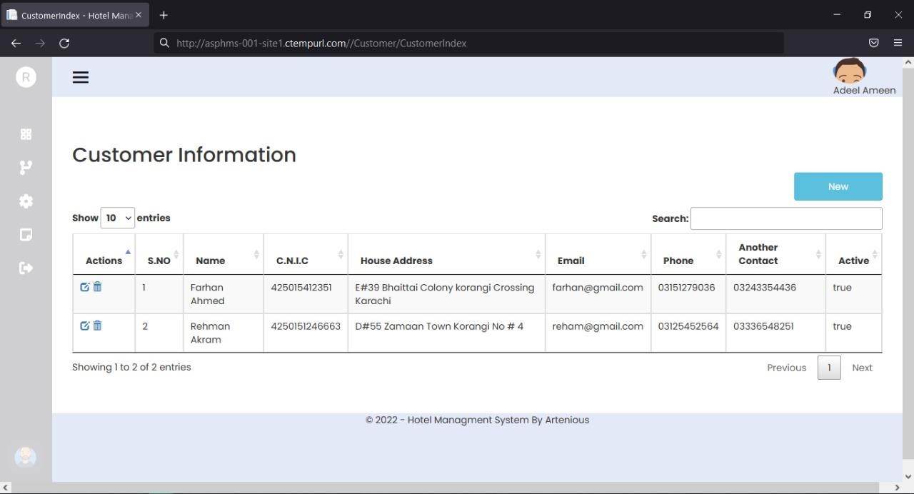

ROOM RESERVATION(TRANSACTION)

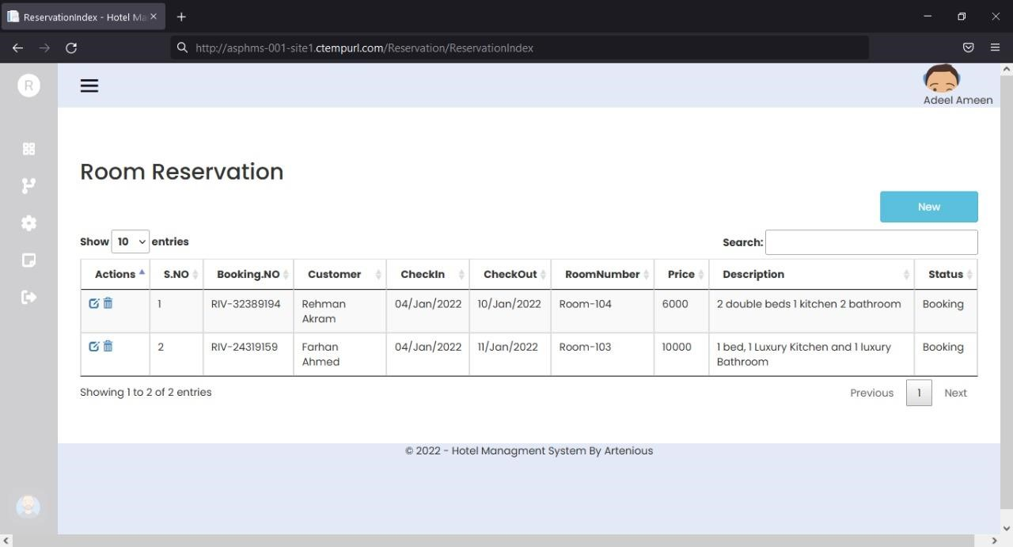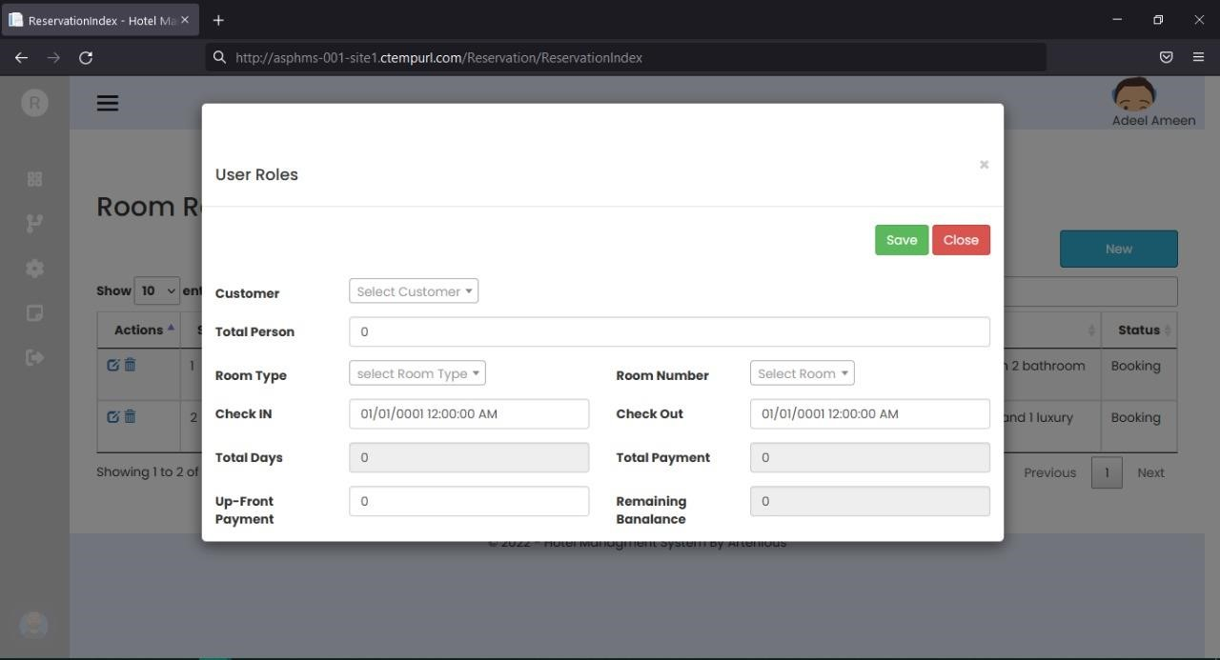

PAYMENT

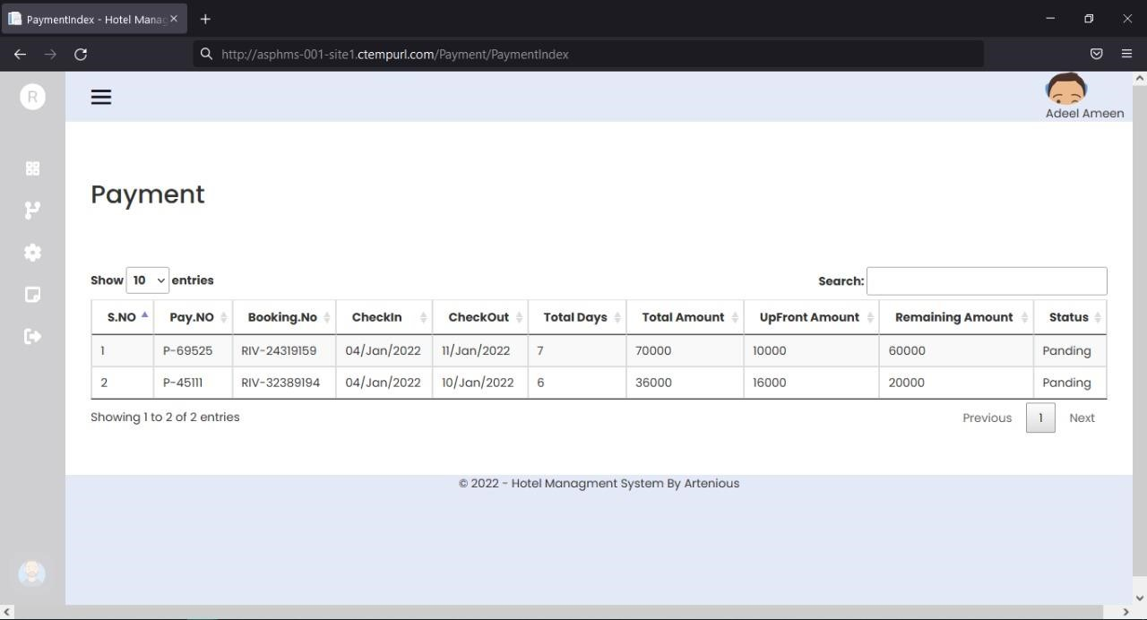

**3.3 Licensing Requirements 3.4 Legal, Copyright, and Other Notices**

**4.1** **AS IS DIAGRAMS**

4.1.1 Use Case Diagram.

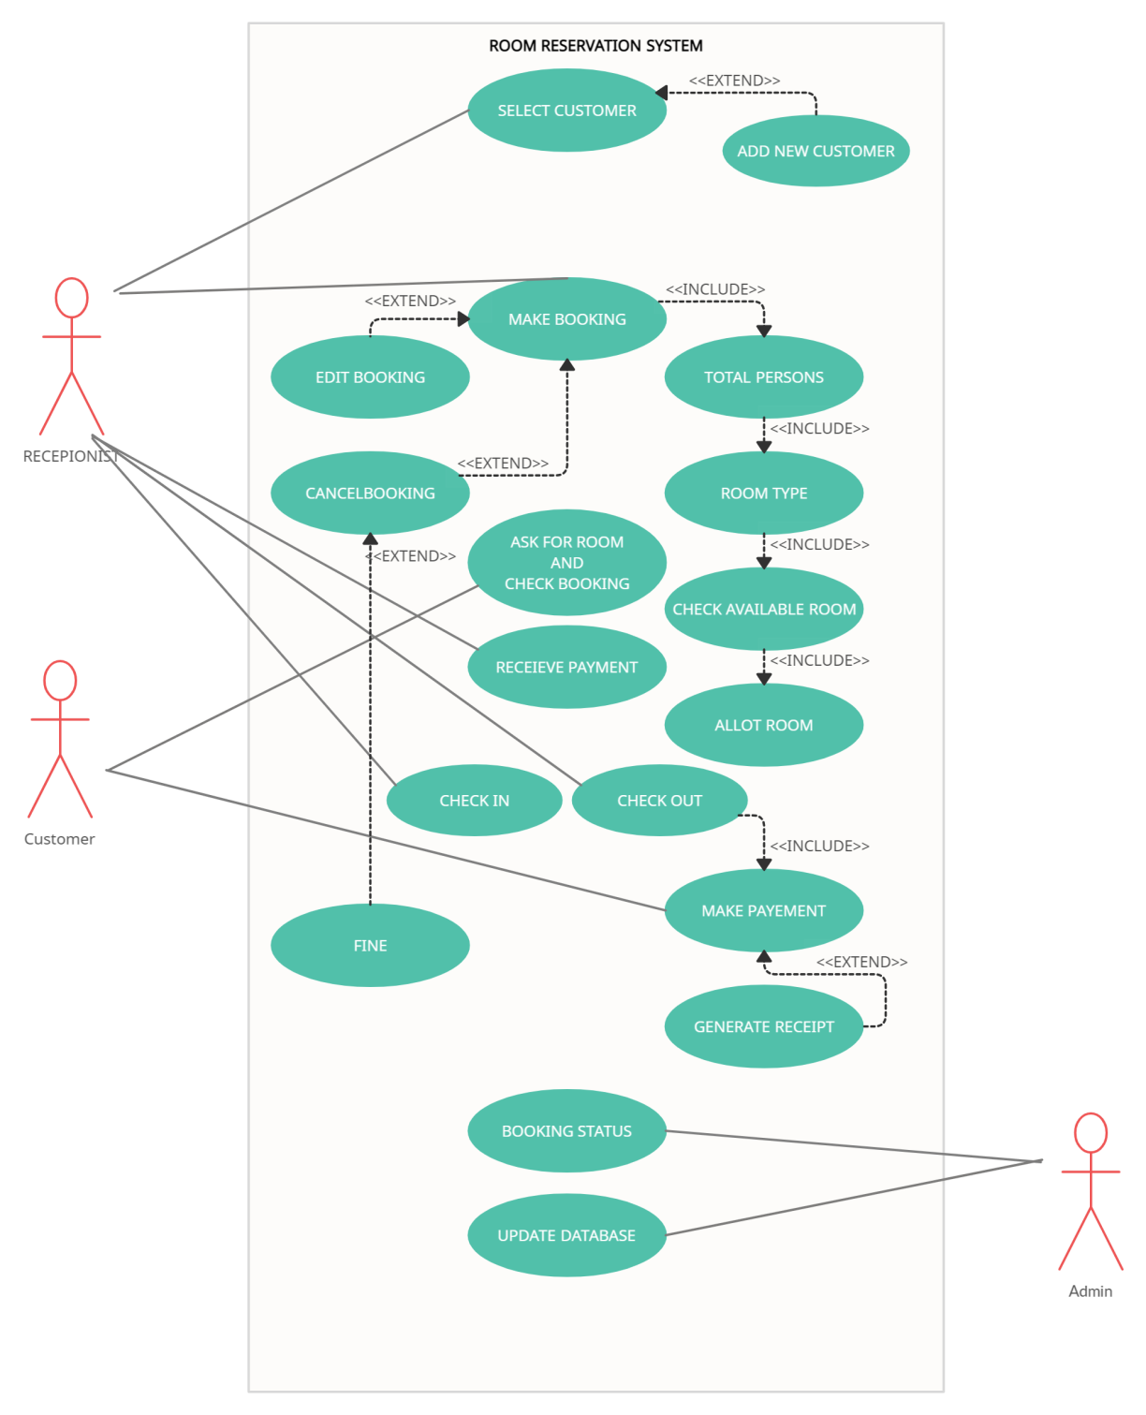

### 4.1.2 Use Case Narration

**Date: 01/01/2022**

**Version: 1.00**

|  |  |  |  |  |
| --- | --- | --- | --- | --- |
| **Use Case Name:** |  | Room Reservation | | Use Case Type  Business Requirements  System Analysis ✓ |
| **Use Case ID:** |  | AS-IS | |
| **Priority:** |  | High | |
| **Source:** |  | Requirements Use Case – As is | |
| **Primary Business actor** |  | Customer(Old Customer)  Customer(New Walk in Customer) | | |
| **Primary system actor** |  | Receptionist | | |
| **Other Participating Actors** |  | Admin | | |
| **Other Interested Stakeholders** | • | Management – Interested in booking activity in order to evaluate Hotel performance and customer satisfaction. | | |
|  | • | Staff – In Order To get more tips and Bonuses | | |
| **Description** |  | This use case describes the event of Room Reservation via  Management system. Receptionist Takes the details/ query of the  Walk-in Customer. Once taken the Details it Books the Room for the Customer If the Desired Customer Room is Available if not available it’s give the next possible available room. On Completion Customer will be given the Key of the room. | | |
| **Precondition** |  | Individual Booking the Room Should have his identity and credentials.  Receptionist Must Login to the System. | | |
| **Trigger** |  | This use case is initiated when the Receptionist selects the Room Reservation Option. | | |
| **Typical Course of Events** |  | **Actor Action** | **System Response** | |
|  | **STEP 1:** Receptionist opens the UI of Adding Room Reservation  **STEP 3:** Selects from the  Customer and Selects the Check in Checkout Date and Total Persons. **STEP 5:** Receptionist Selects Room Type from the Drop Down | **STEP 2:** The System Responds by loads the UI and Give the previous Customer List **STEP 4:** The System Responds by fetching the Room Types According to the Total Persons. **STEP 6:** The System than gives the Available Room Number of the Selected Options. **STEP 7:** After booking the  Room. System will calculate the  Total Amount According to the  Total Days Stayed and Room Type and Total Number of persons. | |

### 4.1.3 Activity Diagram

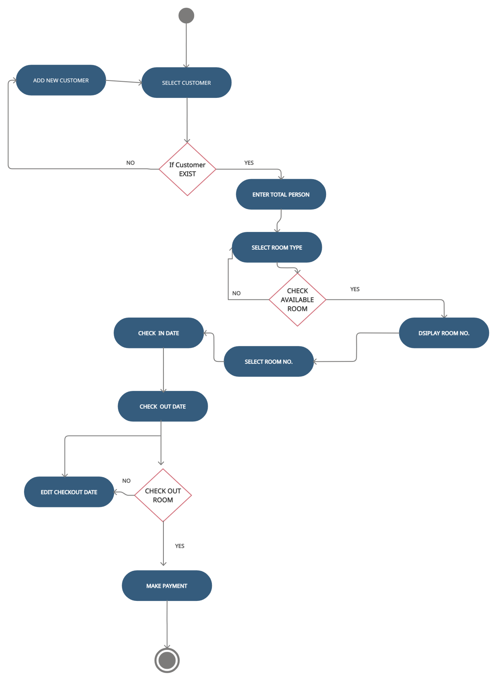

### 4.1.4 Sequence Diagram

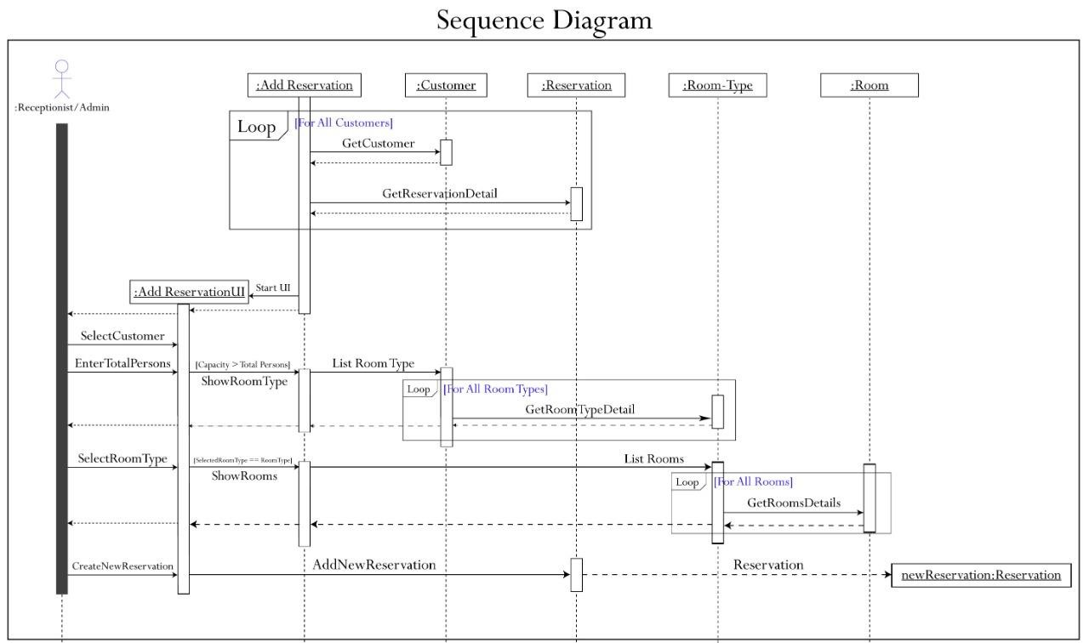

### 4.1.5 Collaborative Diagram

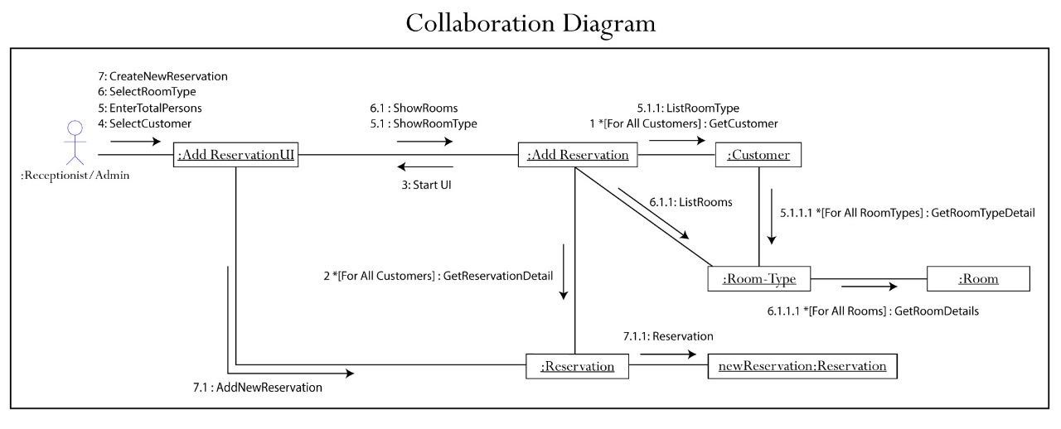

### 4.1.6 State Chart Diagram

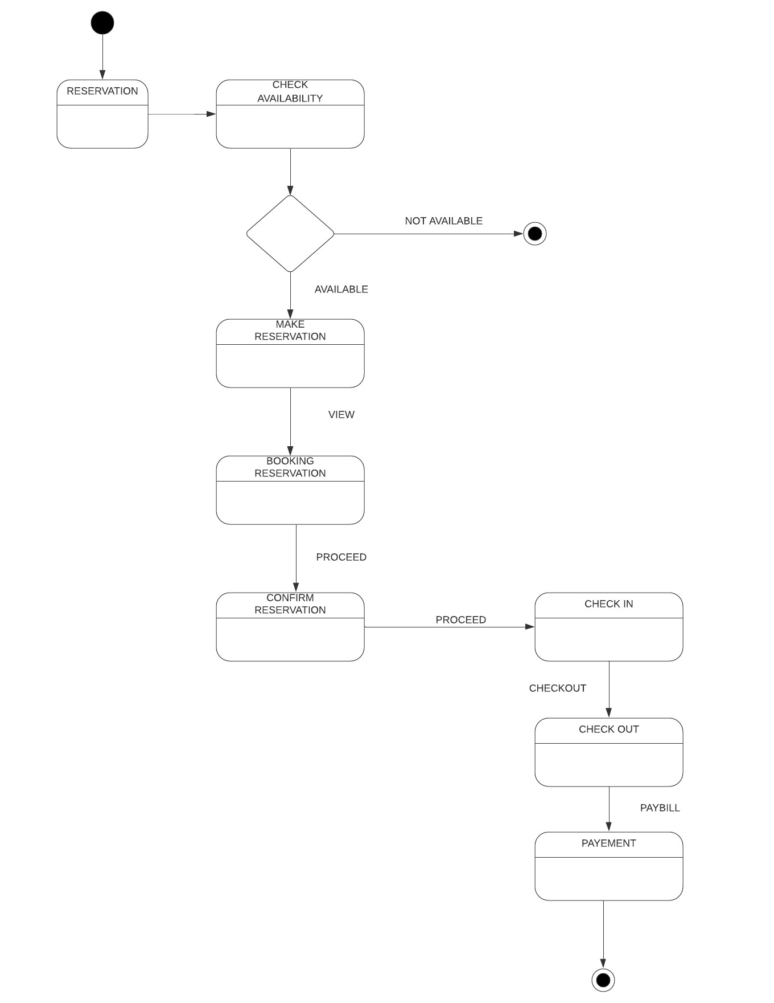

### 4.1.7 Class Diagram

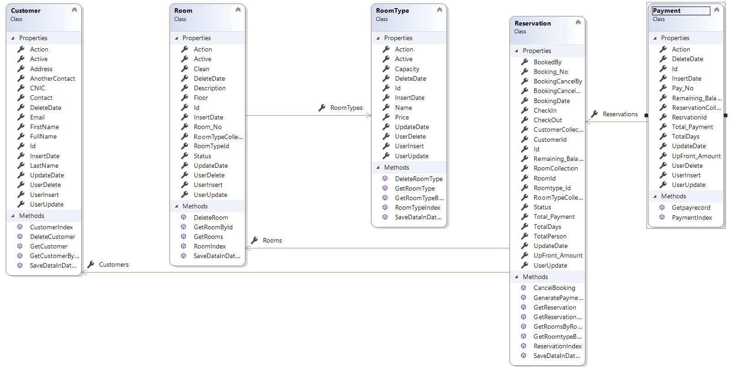

**4.2** **To Be Diagrams**

4.2.1 Use Case Diagram.

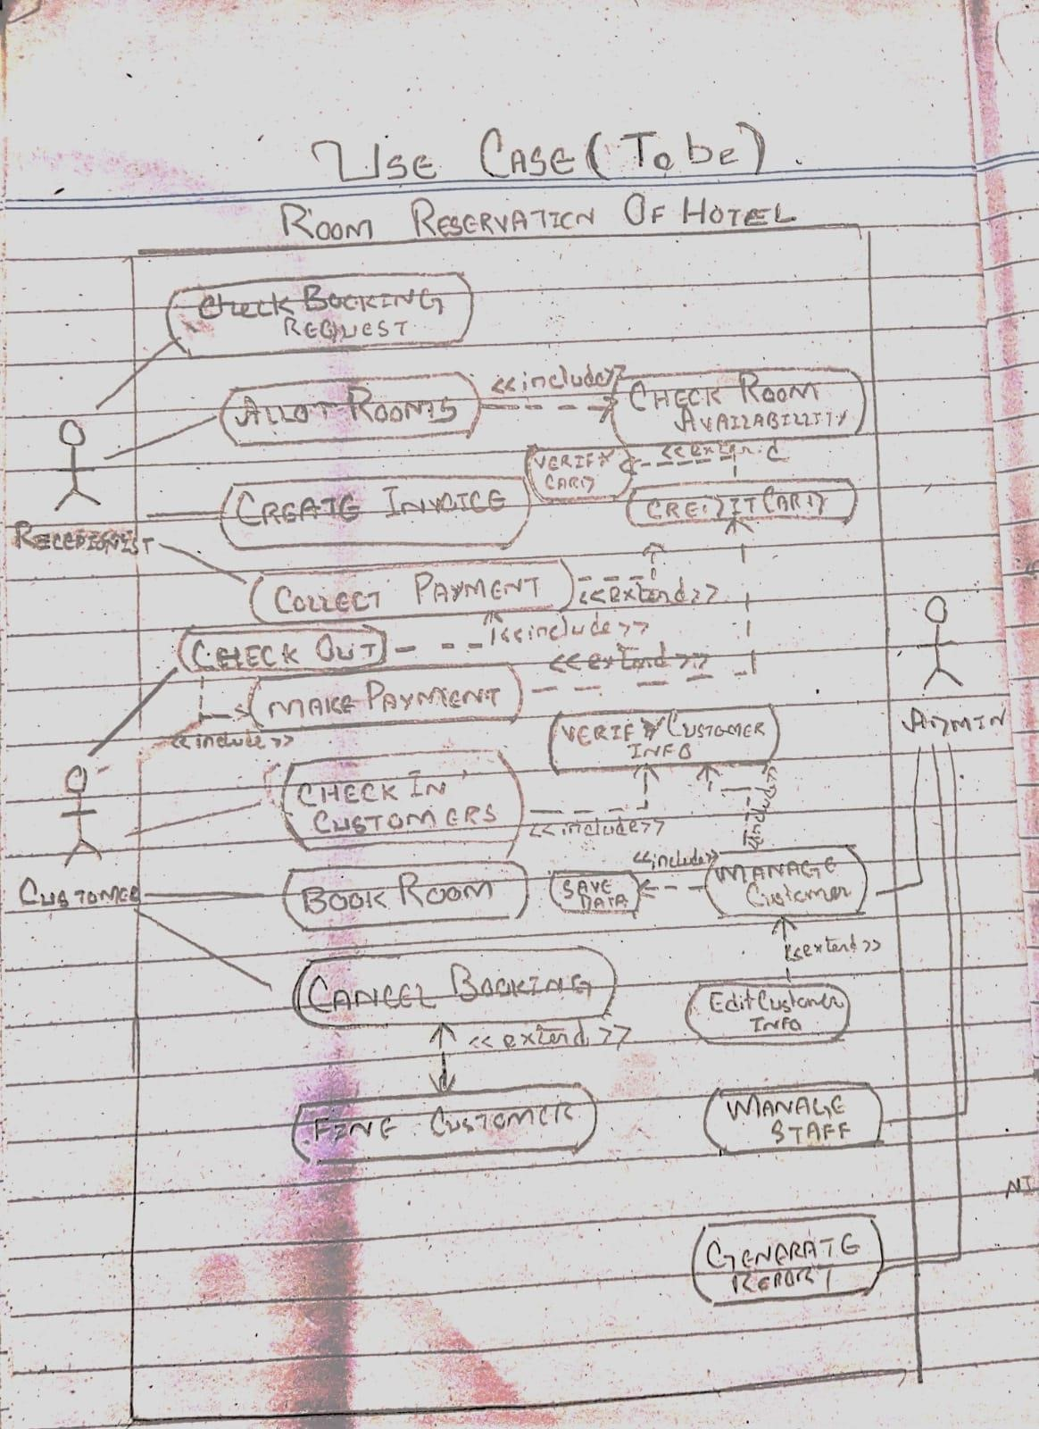

4.2.2 Activity Diagram

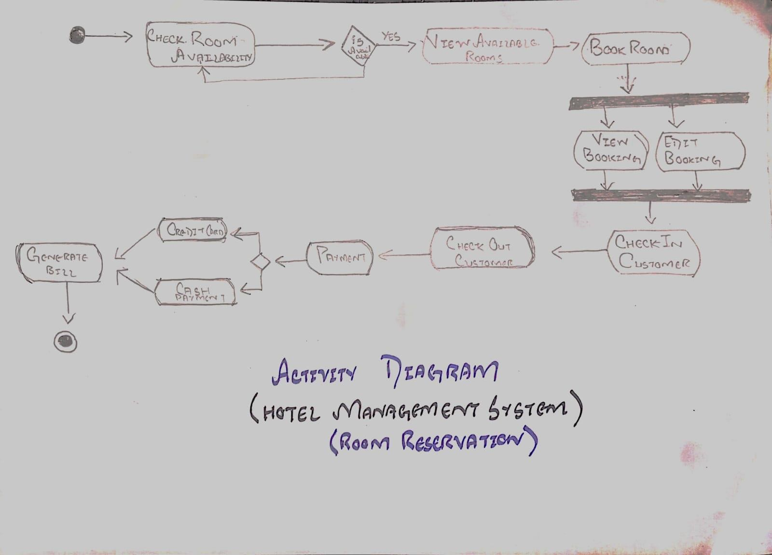

4.2.3 Sequence Diagram

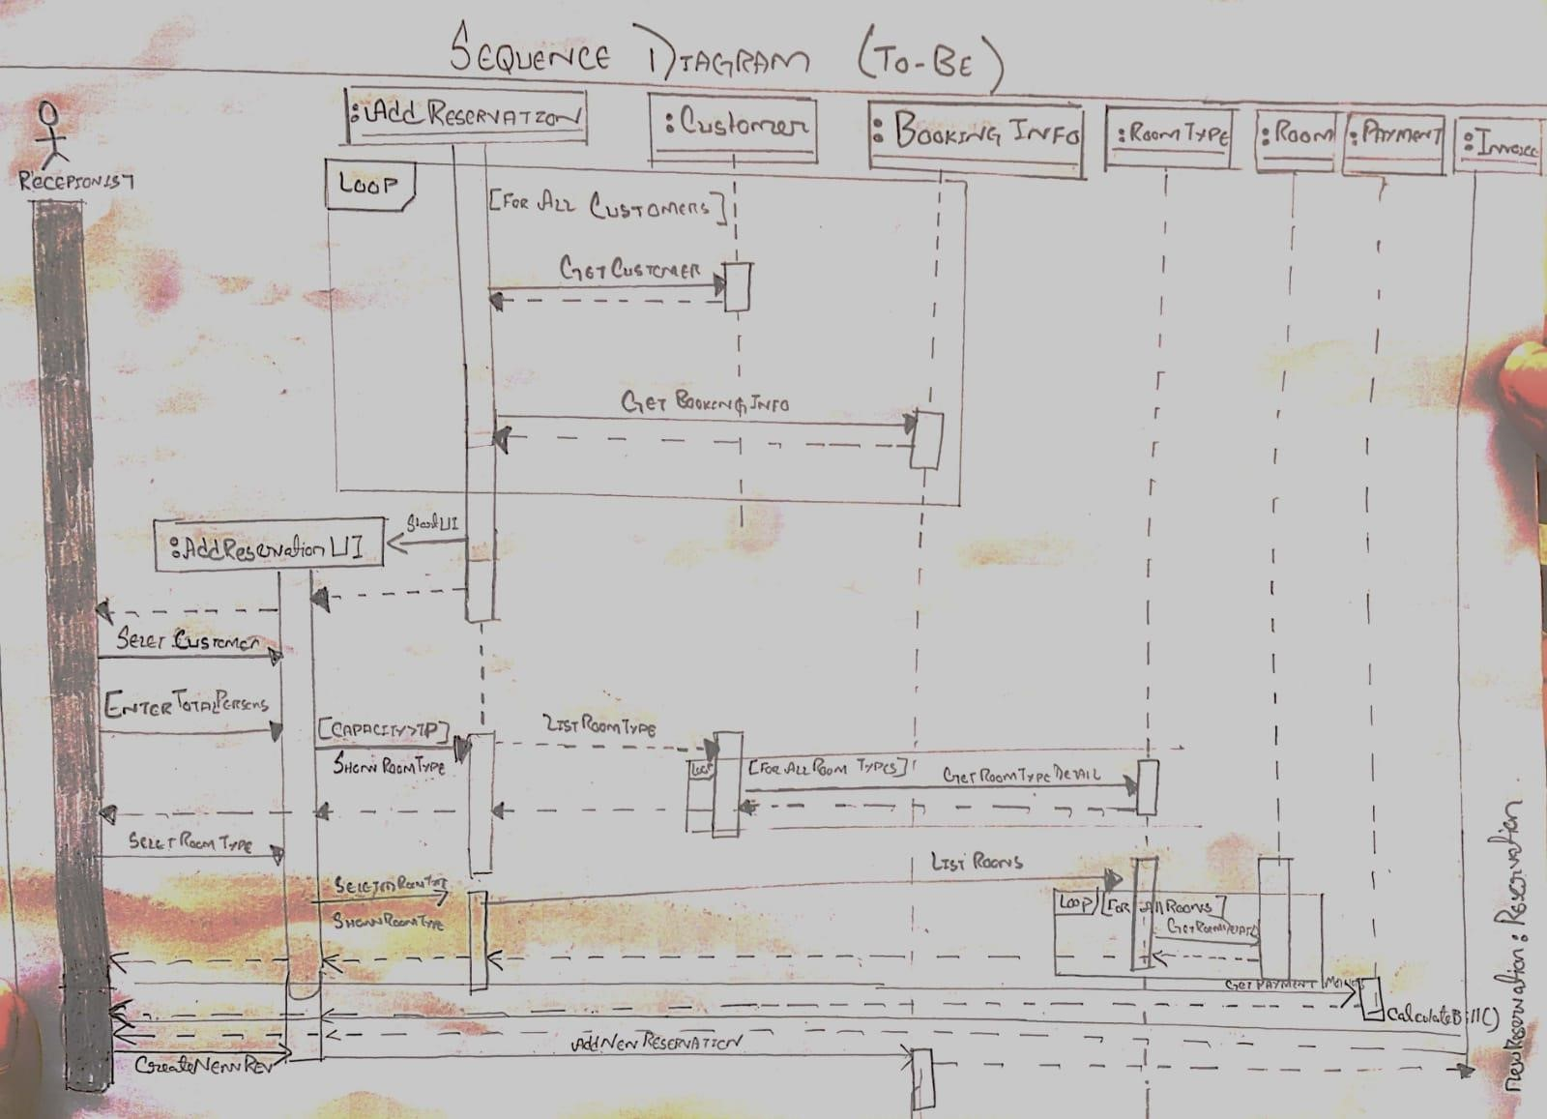

4.2.4 Collaborative Diagram

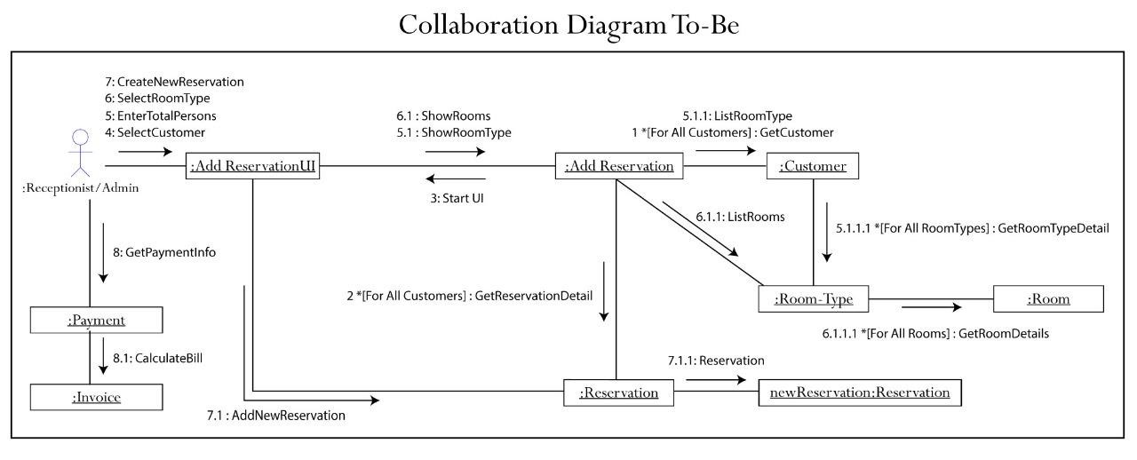

4.2.5 State Chart Diagram



**WEBISTE LINK :** http://asphms-001-site1.ctempurl.com/

**CLICKUP LINK:** https://app.clickup.com/7276110/v/l/6y1je-24

**GIT LINK** : https://github.com/Adeel-web/Hotel-Managment-System.git